Clal logic instructions
Former logic (from AJ):
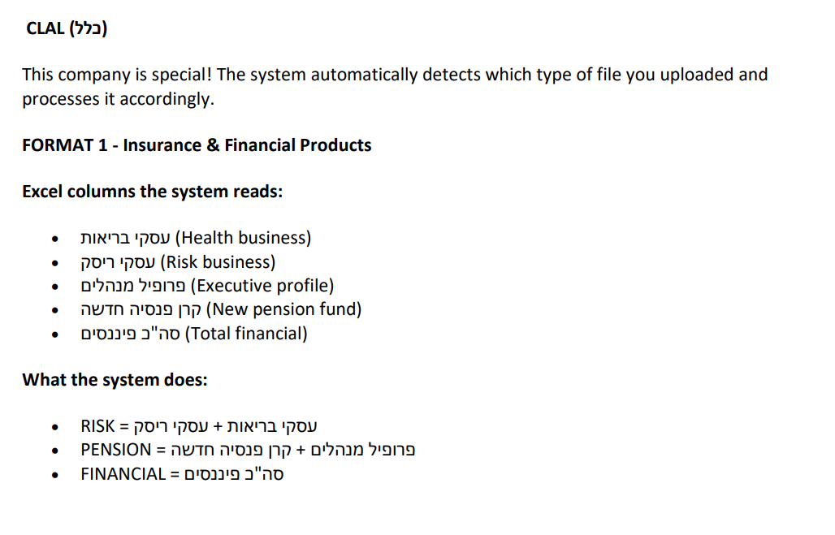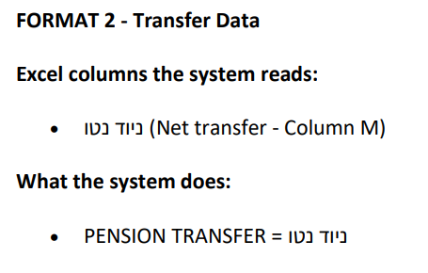
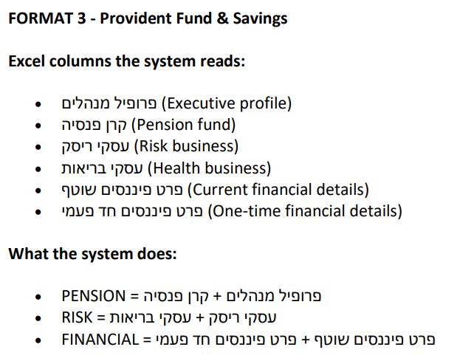

New logic
Format 1-
Same logic- BUT:
A year-to-date cumulative report without a date column.
What you need to do is perform the exact same logic each month. And subtract from the result the sum of all the previous months in that year.

Format 2-
Same logic- BUT:
A year-to-date cumulative report without a date column.
What you need to do is perform the exact same logic each month. And subtract from the result the sum of all the previous months in that year.

Format 3:
Relevant sheet is only "רמת פוליסה"
Read columns: D, H, M, O
Filter by month in Column H (1-12)
Agent ID is in column D.
Sum using Column O
Classifications to products based on the logic – Column M:
Risk = בריאות + ריסק מנהלים + ריסק טהור + ריסק משכנתא
Pension = פנסיה תיק משולב
Financial = חסכון פיננסי

